Tortoise Git – Diff later

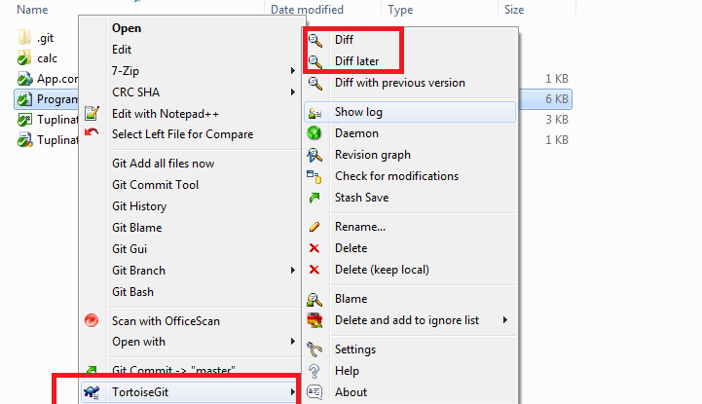

Tortoise git is a useful git tool which can be used to monitor changes in your code base. Use the Diff then the Diff later option to compare the differences between two files.

Diff later is used to compare a file against an earlier version/commit of the same file.

**Green ticks represent no local changes the files are the same as the remote branch**

**red ticks represent local changes in code base**

The colour symbols make it extremely easy to see at a glance what has changed in your code base.

I always use a combination of Tortoise Git along with Git Bash and git inside of Visual studio.